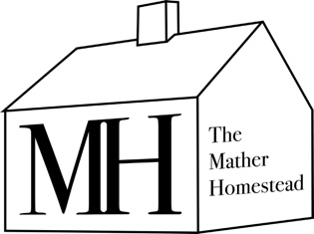

Mather Homestead Teen Board

Description:

The Mather Homestead Teen Board offers local high school students with a passion for history the opportunity to engage deeply with the Homestead’s mission through monthly meetings, volunteer work at events, and participation in educational lectures. As ambassadors and junior docents, Teen Board members gain hands-on experience while contributing ideas, promoting local history, and developing leadership skills.
Commitment: Teen Board participants are expected to attend monthly meetings, which take place on Wednesdays at 7:00 PM during the school year. In addition to attending meetings, each member is required to volunteer at a minimum of five events and attend at least two lectures.
As ambassadors and junior docents of the Mather Homestead, Teen Board members will represent and actively promote the Homestead’s mission and historical significance. Members are encouraged to share their perspectives, contribute ideas for programming, and engage thoughtfully in the Homestead’s activities.
Teen Board members are expected to demonstrate a proactive attitude, dependability, responsiveness, and enthusiasm in all of their responsibilities.
Program fee: $100

Does this sound like you? If so, please see application here:

Application

About the Mather Homestead:

The Mather Homestead is a historic museum and thriving educational center located in Darien, CT. Mather Homestead offers museum tours, hosts school groups, educational lectures, historical reenactments, literature events, family outings and many other events aligned with the mission of learning and enjoyment of the historic property. The home was built in 1778 and not only tells the story of colonial history as experienced by the Mather Family but was also the home of Stephen Tyng Mather, the first director of the National Park System. The Mather Homestead has a rich collection of colonial-era antiques and original archival documents relating to the Mather Family.

